|  |  |
| --- | --- |
|  | |
| THE ASSESSMENT TITLE  Skateboarding made Easy [ST10452505]- [Simon Swart]-WEDE-POE-Part.1 | |
| Student Number: | ST10452504 |
| Programme Code: | Web Development (Introduction) |
| Module Lecturer: | Courtney Young |
| Module Code: | WEDE5020/d/p/w |
| Date of Submission: | 15-08-2024 |

|  |
| --- |
| I hereby declare that I did not plagiarise the content of this assignment and that this is my own work.  Assignment submitted via SafeAssign: (Tick the Box) |

Table of Contents

1 SKATEBOARDING MADE EASY 1

2 Pages: 1

3 Assets 3

4 Reference List 5

# SKATEBOARDING MADE EASY

Port Elizabeth does not have anyone giving skateboarding lessons. There are so many young kids who want to start but get hurt and discouraged because they did not learn how to skateboard properly. So, the idea behind the website would be to tell the user more about skateboarding lessons that would be provided in PE. The target audience of the website spans further than kids who want to learn but also their parents and older skaters who either want to start or re-learn skateboarding.

# Pages:

There are currently 5 pages for this website:

* Home:

This will include vital information to the user and tell them all the services we offer as well as what is to be expected in each class.

The layout will be as follows:

* + Nav bar
  + Logo
  + Video
  + Title
  + Information
  + table
* Our work:

On this page the classes are explained with more detail telling the user more about what they will be learning in the classes.

The layout will be as follows:

* Nav bar
* Logo
* Images
* Information
* Video
* Contact us:

The contact us page has a form to fill in as well as ways to contact us and links to our socials.

The layout will be as follows:

* + Nav bar
  + Logo
  + Email, number and socials
  + Form
  + Video
* Gallery:

The gallery shows images of the coaches in action and some example videos of the tricks you can learn in each class. There is also a YouTube video.

The layout will be as follow:

* Nav bar
* an Image of the coach
* Images
* Videos
* YouTube video
* About us:

The about us page shares the history, vision, mission, and goals of Skateboarding made Easy. There is also a google maps window showing the user where they can find us.

The layout will be as follow:

* + Nav bar
  + Logo
  + Image of coach
  + Information (history, mission, vision, goals)
  + Google maps window

# Assets

This project is all about skateboarding and I have decided to go out and gather my own images and videos eliminating the need to try and find free images and videos online

The only image I took of the internet was the logo I made using Canva (Canva,2024)

Below is some of the images currently on the website:

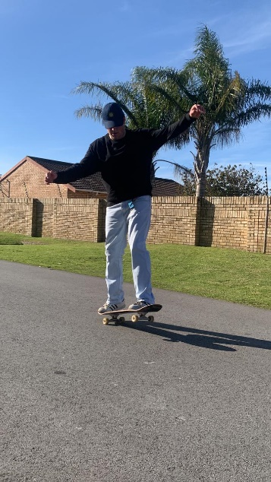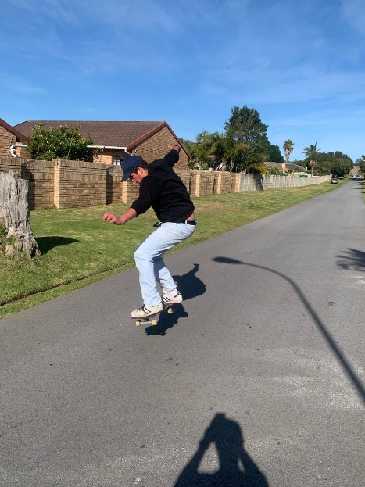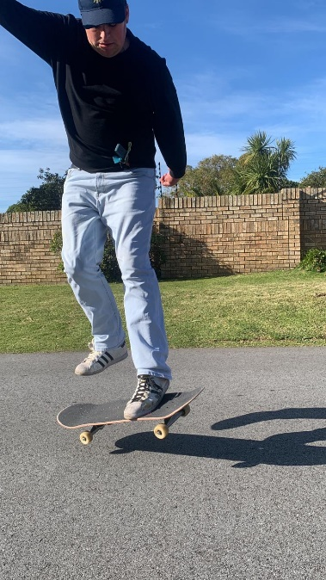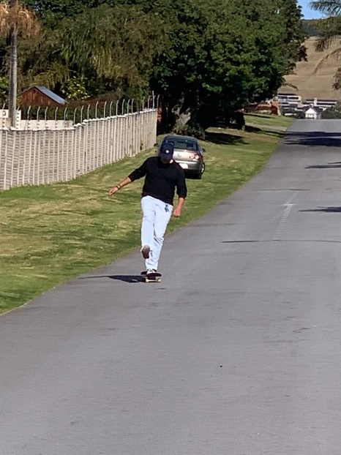

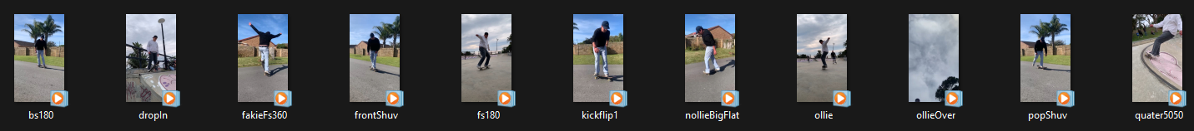

# Reference List

Canva. 2024.Thynk Unlimited. [Website]. Available at: <https://www.canva.com/design/DAGNxLn3yH4/LtuIkE8CdPKOPQA3V10McQ/edit>.[Accessed 14 August 2024]

Kings Beach Skate Park. 2024.Google maps. [Online]. Available at: <https://www.google.com/maps/place/Kings+Beach+Skate+Park/@-33.9733716,25.6421449,17z/data=!3m1!4b1!4m6!3m5!1s0x1e7ad2a155d74cd5:0xbbf7af8538991df2!8m2!3d-33.9733761!4d25.6447252!16s%2Fg%2F11cjgkfwf3?entry=ttu>.[Accessed 14 August 2024].

Skateboarding made Easy presents: How to ollie. 2024.YouTube video, Skateboarding made Easy. [Online]. Available at: <https://www.youtube.com/watch?v=wGZH_fSUTTw>.[Accessed 14 August 2024].

stackoverflow. 2022.Where to set font-family: body or html element? [online]. Available at: <https://stackoverflow.com/questions/42925682/where-to-set-font-family-body-or-html-element>.[Accessed 14 August 2024]

Swart, S. 2024. Quickly Visit on a quarter pipe. [Video] [Personal Collection]. Unpublished.

Swart, S. 2024. Fakie Frontside360. [Video] [Personal Collection]. Unpublished.

Swart, S. 2024.Flatground backside180. [Photograph] [Personal Collection]. Unpublished.

Swart, S. 2024.Flatground kickflip 1. [Photograph] [Personal Collection]. Unpublished.

Swart, S. 2024.Flatground kickflip 2. [Photograph] [Personal Collection]. Unpublished.

Swart, S. 2024.Flatground kickflip 3. [Photograph] [Personal Collection]. Unpublished.

Swart, S. 2024.Flatground kickflip 4. [Photograph] [Personal Collection]. Unpublished.

Swart, S. 2024.Flatground manual. [Photograph] [Personal Collection]. Unpublished.

Swart, S. 2024. Flat ground nollie big spin. [Video] [Personal Collection]. Unpublished.

Swart, S. 2024.Flatground ollie. [Photograph] [Personal Collection]. Unpublished.

Swart, S. 2024. Flat ground Ollie. [Video] [Personal Collection]. Unpublished.

Swart, S. 2024.Flatground pop shuvit. [Photograph] [Personal Collection]. Unpublished.

Swart, S. 2024. Flat ground pop shuvit. [Video] [Personal Collection]. Unpublished.

Swart, S. 2024. Flat ground front shuv. [Video] [Personal Collection]. Unpublished.

Swart, S. 2024. Flat ground frontside180. [Video] [Personal Collection]. Unpublished.

Swart, S. 2024. Flat ground backside 180. [Video] [Personal Collection]. Unpublished.

Swart, S. 2024. 5050 on a quarter pipe. [Video] [Personal Collection]. Unpublished.

Swart, S. 2024. Ollie over camera. [Video] [Personal Collection]. Unpublished.

Swart, S. 2024.Posing with skateboard. [Photograph] [Personal Collection]. Unpublished.

Swart, S. 2024.Riding skateboard. [Photograph] [Personal Collection]. Unpublished.

Swart, S. 2024.Riding skateboard 2. [Photograph] [Personal Collection]. Unpublished.

The IIE. 2024.Web Development (Introduction)[WEDE520]. The Independent Institute of Education:Unpublished.

W3Schools.2024.CSS transform Property. [online]. Available at: <https://www.w3schools.com/cssref/css3_pr_transform.php>.[Accessed 14 August 2024]

W3Schools.2024.HTML <center> Tag. [online]. Available at: <https://www.w3schools.com/tags/tag_center.ASP>.[Accessed 14 August 2024]

W3Schools.2024.HTML <video> autoplay Attribute. [online]. Available at: <https://www.w3schools.com/tags/att_video_autoplay.asp>.[Accessed 14 August 2024]

W3Schools.2024.HTML <video> muted Attribute. [online]. Available at: <https://www.w3schools.com/tags/att_video_muted.asp#:~:text=Definition%20and%20Usage,the%20video%20should%20be%20muted>.[Accessed 14 August 2024]

W3Schools. 2024.How TO - Top Navigation. [online]. Available at: <https://www.w3schools.com/howto/howto_js_topnav.asp>.[Accessed 14 August 2024]

W3Schools.2024.How TO - Responsive Tables. [online]. Available at:https://www.w3schools.com/howto/howto_css_table_responsive.asp[Accessed 26 September 2024]

W3Schools.2024.Media Queries. [online]. Available at:[https://www.w3schools.com/html/html_responsive.asp[](https://www.w3schools.com/html/html_responsive.asp%5b)Accessed 26 September 2024]

W3Schools.2024.CSS max-width Property. [online]. Available at:<https://www.w3schools.com/cssref/pr_dim_max-width.php#:~:text=The%20max%2Dwidth%20property%20defines,width%20property%20has%20no%20effect.>[Accessed 26 September 2024]

W3Schools.2024.CSS border-radius Property. [online]. Available at:<https://www.w3schools.com/cssref/css3_pr_border-radius.php>[Accessed 26 September 2024]

W3Schools.2024.CSS Text Decoration. [online]. Available at:<https://www.w3schools.com/css/css_text_decoration.asp>[Accessed 26 September 2024]

W3Schools.2024.CSS justify-content Property. [online]. Available at: <https://www.w3schools.com/cssref/css3_pr_justify-content.php>[Accessed 26 September 2024]

W3Schools.2024.CSS Flexbox. [online]. Available at: <https://www.w3schools.com/cssref/css3_pr_justify-content.php>[Accessed 26 September 2024]

W3Schools.2024.CSS text-shadow Property. [online]. Available at: <https://www.w3schools.com/cssref/css3_pr_text-shadow.php>[Accessed 26 September 2024]

W3Schools.2024.CSS margin-left Property. [online]. Available at: <https://www.w3schools.com/cssref/pr_margin-left.php>[Accessed 26 September 2024]

W3Schools.2024.CSS margin-right Property. [online]. Available at: <https://www.w3schools.com/cssref/pr_margin-right.php>[Accessed 26 September 2024]

W3Schools.2024.CSS Layout - float and clear. [online]. Available at: [https://www.w3schools.com/css/css_float.asp](https://www.w3schools.com/cssref/pr_margin-right.php)[Accessed 26 September 2024]

W3Schools.2024.CSS align-content Property. [online]. Available at: <https://www.w3schools.com/cssref/css3_pr_align-content.php>[Accessed 26 September 2024]

W3Schools.2024.CSS flex-wrap Property. [online]. Available at: <https://www.w3schools.com/CSSref/css3_pr_flex-wrap.php>[Accessed 26 September 2024]

W3Schools.2024.CSS background-color Property. [online]. Available at: <https://www.w3schools.com/cssref/pr_background-color.php>[Accessed 26 September 2024]

W3Schools.2024.CSS padding Property. [online]. Available at: <https://www.w3schools.com/cssref/pr_padding.php>[Accessed 26 September 2024]

W3Schools.2024.CSS padding Property. [online]. Available at: <https://www.w3schools.com/cssref/pr_padding.php>[Accessed 26 September 2024]

W3Schools.2024.CSS Gradients. [online]. Available at:<https://www.w3schools.com/css/css3_gradients.asp>[Accessed 26 September 2024]